**YOW Airport Pesticide Compliance Review –Scoring & Commentary**

| **Section** | **#** | **Question (abridged)** | **Response** | **Compliance** | **Comments/Recommendations** |
| --- | --- | --- | --- | --- | --- |
| 1 | 1.1 | Public notification requirements met? | Yes* | 1 | Good tenant notification; confirm tenant list and exemption status for full compliance. |
| 1 | 1.2 | Records of notifications available? | Yes | 1 | Email records maintained; compliant. |
| 1 | 1.3 | Fire department notified of storage if required? | Yes | 1 | Compliant. |
| 2 | 2.1 | All applicators licensed/certified? | Yes | 1 | All listed as certified; compliant. |
| 2 | 2.2 | Copies of licenses/certificates on file? | Yes | 1 | Compliant. |
| 2 | 2.3 | Required permits for use/storage up to date? | N/A | - | No permits required beyond applicator licenses. |
| 3 | 3.1 | All pesticides registered and approved? | Yes | 1 | Product registered; compliant. |
| 3 | 3.2 | Containers have current, legible labels? | Yes | 1 | Compliant. |
| 3 | 3.3 | Only proper, undamaged containers stored? | Yes | 1 | Compliant. |
| 4 | 4.1 | Pesticides stored in secure, locked areas? | Yes* | 1 | Stored securely, but clarify “No locks stored in Bay”—ensure all storage is locked. |
| 4 | 4.2 | Secondary containment for liquid pesticides? | No | 0 | Not compliant; introduce secondary containment for any liquids stored. |
| 4 | 4.3 | Storage areas marked, separated from food/water? | No* | 0 | Areas not marked; recommend clear signage for compliance. |
| 4 | 4.4 | Storage/handling areas inspected regularly? | Yes | 1 | Compliant via WHSC inspections. |
| 5 | 5.1 | Buffer zones mapped and respected? | Yes* | 1 | Buffer zones respected, but periodic review recommended for new sensitive features. |
| 5 | 5.2 | Application records available (weather, location, method)? | Partial | 0 | Records available, but do not specify weather/method. Update record templates. |
| 5 | 5.3 | Only permitted pesticides, label directions followed? | Yes | 1 | Compliant. |
| 5 | 5.4 | Integrated pest management (IPM) practiced/documented? | Partial | 0 | Some IPM elements via wildlife management, but not fully documented. Formalize IPM. |
| 5 | 5.5 | Spray equipment calibration records kept? | No | 0 | No formal records. Introduce calibration/maintenance recordkeeping. |
| 6 | 6.1 | All use records (product, amount, date, etc.) maintained? | Partial | 0 | Maps and dates kept; need to add product amounts and ensure compliance with regulations. |
| 6 | 6.2 | Annual pesticide use report submitted? | No | 0 | Not submitted. Clarify if federal exemption applies, otherwise implement reporting. |
| 6 | 6.3 | Disposal, spills, incidents records maintained? | Yes | 1 | Vortex system used; compliant. |
| 6 | 6.4 | Records retained at least 5 years? | Yes | 1 | Compliant. |
| 7 | 7.1 | Unused pesticides/containers disposed via approved channels? | Yes | 1 | Supplier picks up; compliant. |
| 7 | 7.2 | Spill response materials/plans at storage and application sites? | Yes | 1 | Spill kits and fire services in place; compliant. |
| 7 | 7.3 | All incidents reported as required? | Yes | 1 | Vortex/AOCC system; compliant. |
| 8 | 8.1 | Procedures to prevent use of banned/restricted pesticides? | Partial | 0 | PAR III use justified; formalize a banned/restricted product screening procedure. |
| 8 | 8.2 | Applications only under suitable weather/site conditions? | Yes | 1 | Daytime, no rain/wind; compliant. |
| 8 | 8.3 | Regular self-inspections or compliance audits? | No | 0 | Not conducted. Recommend annual self-audits. |

**Scoring Summary**

* **Total Questions Answered (excluding N/A):** 27
* **Compliant (“Yes”):** 18
* **Partial:** 4
* **Non-Compliant (“No”):** 5

**Compliance Score:**

**18/27 = 67% (Compliant)**

* **Partial/Needs Improvement:** 4/27 = 15%
* **Non-Compliant:** 5/27 = 19%

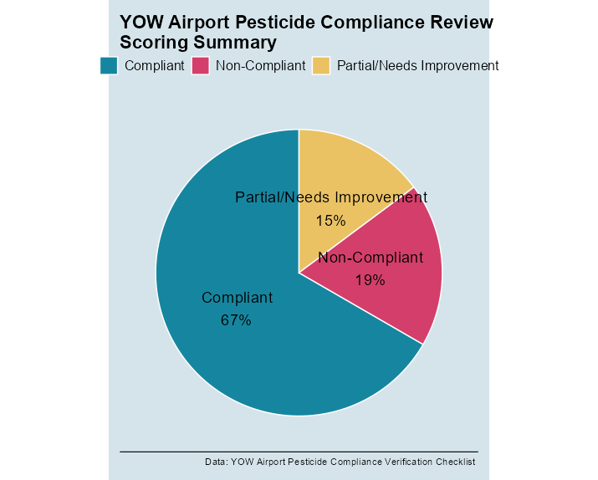

**Key Recommendations for Compliance Improvement**

1. **Secondary Containment:**
   * Immediately add spill containment for any liquid pesticide storage areas.
2. **Marking Storage Areas:**
   * Clearly mark all pesticide storage areas, even if food/water is not present.
3. **Recordkeeping:**
   * Update application records to include weather, method, and precise amounts.
   * Introduce spray equipment calibration and maintenance logs.
4. **IPM Documentation:**
   * Develop and document a formal IPM plan, including pest monitoring and non-chemical controls.
5. **Reporting:**
   * Clarify federal exemption status for annual reporting; if required, submit as per Ontario/federal guidance.
6. **Self-Inspections/Audits:**
   * Implement annual compliance self-audits and document findings.
7. **Banned/Restricted Product Checks:**
   * Develop a documented procedure to screen against banned/restricted pesticide lists before use.

**General Comments**

* Program is **strong in operational safety and basic regulatory compliance**.
* **Documentation, recordkeeping, and formalization** of some practices are areas for improvement.
* **Adoption of a structured IPM program** and regular compliance audits will close most remaining gaps.

**Prepared by:**  
Patrick Stephenson, Senior Pesticide Regulatory Consultant – Canada  
Date: 2025-06-20